# Arduino Mega and Arduino Leonardo Microcontrollers

The Arduino Mega 2560 and Arduino Leonardo are two widely used microcontroller, each offering distinct features that make them valuable in small-scale and low-cost satellite projects. Both are based on 8-bit AVR microcontrollers running at 16 MHz and operate at 5V logic, but they differ significantly in I/O capabilities, memory size, and communication interfaces.

## Arduino Mega 2560

The Arduino Mega 2560 Rev3 is a high-performance development board designed for advanced and multi-interface applications. It is built around the ATmega2560 microcontroller, making it suitable for complex embedded systems and satellite subsystem simulations where multiple peripherals must be monitored and controlled simultaneously.

* **Processor:**  
  Equipped with the ATmega2560, an 8-bit AVR RISC-based microcontroller operating at 16 MHz, the Mega 2560 delivers stable performance for control-intensive tasks. The 16 MHz crystal oscillator provides accurate timing, essential for time-sensitive satellite applications.
* **Memory:**
  + **Flash Memory:** Offers 256 KB of program memory, with 8 KB reserved for the bootloader, enabling deployment of large firmware with robust functionality.
  + **SRAM:** Includes 8 KB of static RAM, sufficient for handling moderate data buffers, temporary sensor readings, and telemetry queues.
  + **EEPROM:** Provides 4 KB of non-volatile memory for storing persistent settings, calibration data, or logs.
* **Power Supply and Voltage Tolerance:**
  + Operates at a logic level of 5V and is compatible with many sensors and actuators.
  + Accepts input voltage from 7–12V via barrel jack or VIN pin. The onboard voltage regulator manages internal voltage levels safely.
  + The 3.3V pin supplies up to 50 mA, useful for powering low-current 3.3V devices.
  + Each I/O pin can safely provide or sink up to 20 mA, with an absolute maximum of 40 mA, making it suitable for direct LED drive or signal control without the need for transistors in low-power applications.
* **I/O Capabilities:**
  + 54 digital I/O pins, with 15 capable of PWM output, allow the board to interface with a large number of digital sensors, switches, relays, or actuators.
  + 16 analog input pins support 10-bit resolution ADC, suitable for monitoring analog signals like temperature, voltage levels, or sensor outputs.
  + PWM pins can be configured for power control of devices like motors, LEDs, and DC/DC converters in EPS systems.
* **Communication Interfaces:**
  + Features 4 hardware UARTs (Serial, Serial1, Serial2, Serial3), ideal for communicating with multiple serial devices such as radios, GPS modules, or telemetry units.
  + Includes 1 I²C (TWI) interface for sensors and peripherals with addressable communication.
  + 1 SPI interface for high-speed data communication with SD cards, shift registers, or radio modules.
* **USB Connectivity:**  
  Uses an ATmega16U2 chip as a USB-to-serial converter, enabling easy programming and serial monitoring from a PC. The separate USB controller ensures stable operation without interrupting MCU processing.
* **Physical Dimensions and Weight:**  
  Measures 101.52 mm × 53.3 mm, and weighs approximately 37 grams, making it relatively large but mechanically stable for mounting in development testbeds.

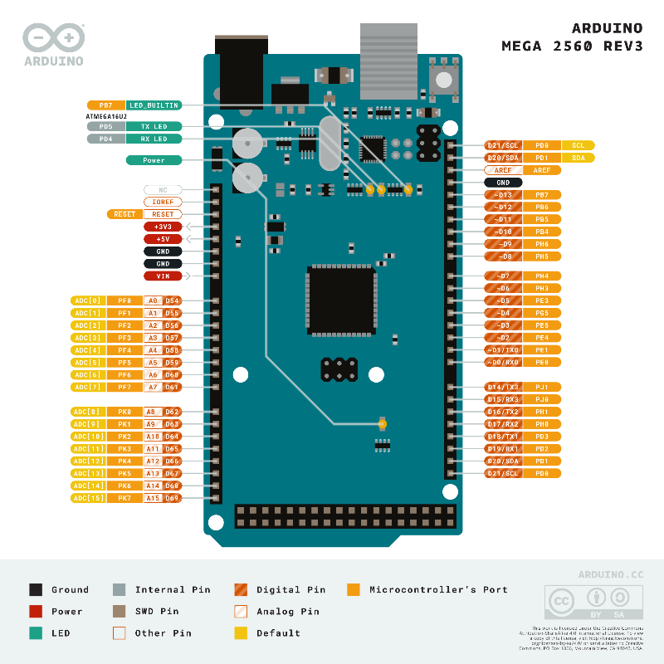

**Advantages**

1. **Extensive I/O Capability**

With **54 digital pins** (15 PWM) and **16 analog inputs**, it offers flexibility for interfacing with multiple subsystems, which is ideal for satellite payloads with complex wiring and parallel sensor arrays.

1. **Multiple Hardware Serial Ports (4 UARTs)**

Enables **simultaneous communication with multiple peripherals**, such as GPS, telemetry radios, and sensor modules—crucial for On-Board Computers (OBCs) or Telemetry, Command, and Data Handling units.

1. **Large Program and Data Memory**

With **256 KB of flash** and **8 KB of SRAM**, it can support larger firmware with structured task management and buffer space for sensor data or command queuing.

1. **Modular Development Support**

Compatible with many Arduino **shields** and **sensor modules**, the board can be rapidly adapted for educational and prototyping use in aerospace or research environments.

1. **Robust Power Handling**

It is designed to operate reliably with **up to 20 mA per I/O pin**, and can source 3.3V at 50 mA, which is suitable for many external sensor systems without requiring additional regulators.

**Disadvantages**

1. **Large and Heavier**

At over **100 mm in length and 37 g**, the Mega is physically bulky, making it less suitable for compact payloads or dense satellite subsystems where PCB space is limited. However, using only the microcontroller chip allows for custom PCB design, enabling significant reductions in physical size, weight, and power consumption.

1. **Higher Power Consumption**

The multiple onboard chips (ATmega2560 + ATmega16U2 for USB) contribute to **increased idle current**, which must be accounted for in EPS design and may drain batteries faster.

1. **5V Logic Only**

Not natively compatible with modern 3.3V sensors without logic level shifting, which introduces complexity and potential signal integrity issues.

1. **No Native USB or HID Support**

Cannot function as a USB keyboard, mouse, or native COM port emulator without additional firmware; less useful in PC simulation or human-interface contexts.

1. **Limited Processing Speed**

Despite its memory, the **16 MHz 8-bit architecture** lacks advanced processing features (e.g., floating-point unit), limiting performance in real-time control or image processing.

## Arduino Leonardo

The Arduino Leonardois a compact and cost-effective microcontroller board ideal for simpler or USB-interfaced systems. It is powered by the ATmega32U4 microcontroller, which includes built-in USB capability, allowing the board to emulate USB peripherals such as a mouse, keyboard, or virtual COM port.

* **Processor:**  
  Incorporates the ATmega32U4, a versatile 8-bit AVR MCU running at 16 MHz. It supports full USB device functionality, eliminating the need for a separate USB-to-serial chip and reducing board complexity and power consumption during ground-based testing.
* **Memory:**
  + **Flash Memory:** Contains 32 KB of program memory, with 4 KB reserved for the bootloader, sufficient for smaller or task-specific firmware routines.
  + **SRAM:** Offers 2.5 KB of RAM, limiting the amount of simultaneous data it can buffer but enough for light telemetry or control applications.
  + **EEPROM:** Features 1 KB of onboard EEPROM for storing calibration constants, telemetry logs, or system settings between power cycles.
* **Power Supply and Voltage Tolerance:**
  + Operates at 5V logic, compatible with legacy 5V sensors and actuators.
  + Accepts input voltages from 7–12V via barrel jack or VIN pin, regulated down for safe operation.
  + Each digital pin can source or sink up to 40 mA, allowing simple peripherals like status LEDs or low-power drivers to be connected directly.
* **I/O Capabilities:**
  + Provides 20 digital I/O pins, including 7 PWM-capable outputs, making it suitable for basic control of actuators and dimmable components.
  + Has 12 analog input pins, connected to a 10-bit ADC for reading voltages from sensors, potentiometers, or monitoring circuits.
* **Communication Interfaces:**
  + Includes 1 hardware UART (Serial1) for communication with serial devices such as GPS or radios.
  + Supports I²C (TWI) via digital pins 2 (SDA) and 3 (SCL) for addressable devices.
  + SPI communication is available through the dedicated ICSP header, freeing up digital pins for other tasks.
* **USB Connectivity:**  
  The standout feature is its native USB 2.0 interface, allowing the Leonardo to appear as multiple USB devices simultaneously (e.g., mouse + keyboard + serial). This feature makes it especially well-suited for ground-testing, human-interfacing, or simulation tools.
* **Physical Dimensions and Weight:**  
  Measures 68.6 mm × 53.3 mm, and weighs approximately 20 grams, offering a smaller footprint compared to the Mega while retaining enough headers for moderate peripheral interfacing.

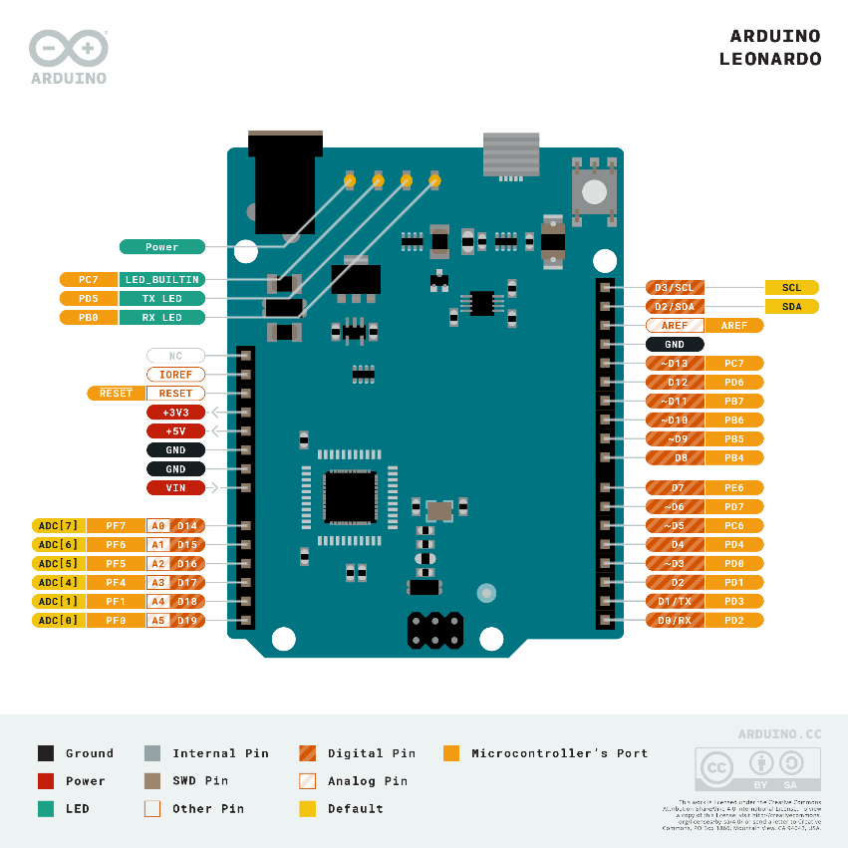

**Advantages**

1. **Compact Size and Lightweight**

It is more space-efficient and easier to integrate into compact satellite modules or small payload enclosures.

1. **Built-in USB Capability**

The native USB support allows the board to act as a USB keyboard, mouse, joystick, or virtual COM port, which is useful for ground testing, PC-based simulations, or in applications where operator input is needed.

1. **Simplified Hardware Design**

No external USB-to-serial chip reduces component count and potential failure points, making the board slightly more power-efficient and less electrically noisy.

1. **Sufficient Analog Input Capability for Basic EPS or Sensor Tasks**

Offers 12 analog inputs, allowing for decent coverage in small-scale EPS monitoring or multi-sensor experiments.

1. **Low Cost and High Availability**

It is cheaper, making it attractive for budget-conscious educational projects or single-subsystem testing.

**Disadvantages**

1. **Limited Serial Communication Interfaces**

Only one hardware UART (Serial1) restricts the number of serial devices it can communicate with simultaneously, making it unsuitable for complex systems involving multiple radios, GPS, or UART-based sensors.

1. **Smaller Memory Size**

With only 32 KB flash and 2.5 KB SRAM, it becomes constrained in applications involving multiple tasks, logging, or sensor data buffering.

1. **Fewer I/O and PWM Channels**

Compared to the Mega, its 20 digital pins and 7 PWM outputs limit the number of actuators or sensors it can drive/control directly.

1. **No Independent USB Interface**

While it can emulate USB devices, this USB port is also used for programming and debugging, which can cause functional overlaps and inconvenience in embedded setups.

1. **Still Uses 5V Logic**

Like the Mega, it operates at 5V logic, which limits compatibility with modern 3.3V sensor modules without using level shifters.

1. **Not Ideal for Centralized Subsystem Control**

Better suited for dedicated or single-function roles, such as USB interface simulation or one-sensor payload control, rather than managing integrated subsystems.

## Subsystem Suitability in Hobby Satellite Development

**1. Electrical Power System (EPS)**

The Mega is well suited for EPS control due to its multiple analog inputs and PWM outputs, enabling monitoring of voltage and current across multiple power buses and control of power switches. The 16 ADC channels and 15 PWM outputs make it possible to implement features like MPPT (maximum power point tracking), battery charging, and fault protection.

The Leonardo can handle basic EPS tasks such as monitoring a small number of analog sensors and toggling relays or switches. Its 12 ADC channels are sufficient for simple EPS tasks, and its USB support is useful during ground simulation and testing phases.

**2. On-Board Computer (OBC)**

The Arduino Mega is favorable for use as an On-Board Computer in hobbyist satellites. Its flash memory and RAM, along with multiple UART ports, allow it to interface simultaneously with subsystems such as EPS, ADCS, telemetry radios, and payload sensors. Its watchdog timer and brown-out detection provide basic reliability for long-duration tasks, and similar microcontroller chips have been used in actual satellite missions like ArduSat.

**3. Attitude Determination and Control System (ADCS)**

The Mega supports multiple PWM and ADC channels for driving actuators (like magnetorquers) and reading from sun sensors or magnetometers. Its multiple serial ports are beneficial for interfacing with Internal Measurement Units or gyroscopes.

**4. Payload Management**

Both boards can be used for basic payload control, such as data acquisition from environmental sensors or logging to an SD card. The Mega’s extra memory and I/O make it more suitable for interfacing with multiple sensors or SD storage simultaneously, while the Leonardo is adequate for simple sensor experiments or single-device payloads.

Neither board is capable of handling high-throughput imaging payloads or heavy real-time processing, but both are suitable for low-data-rate scientific payloads.

**5. Telemetry, Command, and Data Handling (TC&DH)**

The Mega’s multiple UARTs allow it to manage communication with multiple radios, while concurrently handling commands and internal subsystem telemetry. Its memory and pin count allow for implementation of packet parsing, storage, and simple error correction logic.

The Leonardo is more restricted, with only one UART. It can still function in basic telemetry applications but is not ideal for systems needing multiple serial connections.

**6. Communication System**

While neither board contains an onboard RF front-end, both can interface with communication modules (e.g., LoRa, UHF, Bluetooth) via UART or SPI. The Mega’s expanded I/O and multiple communication buses make it preferable for managing multiple devices or implementing serial protocols.

## Cost and Availability

Both the **Arduino Mega 2560** and **Arduino Leonardo** boards are widely available and affordable, making them accessible for **hobby satellite development**. Their standalone microcontroller chips are also available for more compact, power-efficient, and custom PCB designs, which are essential for systems such as in a satellite payload.

* **Arduino Mega 2560 Board**: Typically costs **Ksh. 2,100 – 2,700**
* **ATmega2560 Microcontroller Chip** (for Mega): Approximately **Ksh. 1400**
* **Arduino Leonardo Board**: Priced lower, at **Ksh. 1,500 – 2,100**
* **ATmega32U4 Microcontroller Chip** (for Leonardo): Approximately **Ksh. 600**

For **prototyping or ground simulation**, the full boards are cost-effective and easier to implement.

## Conclusion and Recommendation

The comparison between the Arduino Mega 2560 and Arduino Leonardo highlights that while both are valuable microcontrollers in hobby satellite development, they can serve different roles based on their technical capabilities.

The **Arduino Mega 2560** is recommended for use in the **On-Board Computer (OBC)** subsystem of a hobby satellite project. Its architecture offers critical features that align well with the functional requirements of an OBC.

* **Multiple Serial Interfaces:** The Mega provides four hardware UARTs, allowing it to communicate simultaneously with multiple serial devices such as telemetry radios, GPS modules, IMUs, and ground-test interfaces. This reduces the need for software-based serial emulation, which can introduce delays and data loss under high communication loads.
* **Ample Memory and I/O Capability:** With 256 KB of flash memory and 8 KB of SRAM, the Mega can accommodate more complex firmware, including command parsing, data packet handling, and error detection routines. Its 54 digital I/O pins and 16 analog inputs make it highly flexible for interfacing with a wide range of satellite subsystems and sensors.